Personalekontoret
Dato: 06-02-2023
Sagsnr.: 23/5284
Sagsbehandler: Annette Havmand
Direkte tlf.: 7376 7162
E-mail: ahav@aabenraa.dk

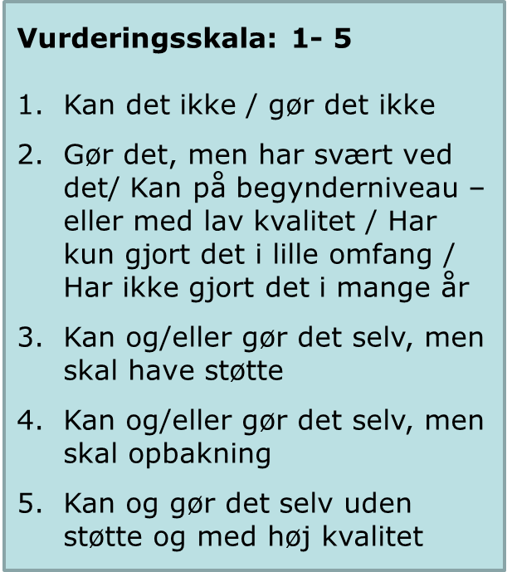
Prioriterings- og vurderingsskema

Stilling som xxxxx

Ansøgers navn:_______________________________

Faglige kompetencer
 | 1 | 2 | 3 | 4 | 5
Personlige kompetencer
Andet

Notater

Ansøgers navn:________________________________________________________

Ansøgerens værdier:____________________________________________________
_______________________________________________________________________________________________________________________________________________________________________________________________________________

Selvindsigt og refleksion:_________________________________________________
_________________________________________________________________________________________________________________________________________________________________________________________________________________________________________________________________________________________________________________________________________________________

Andre iagtagelser:______________________________________________________
_____________________________________________________________________
_______________________________________________________________________________________________________________________________________________________________________________________________________________________________________________________________________________

